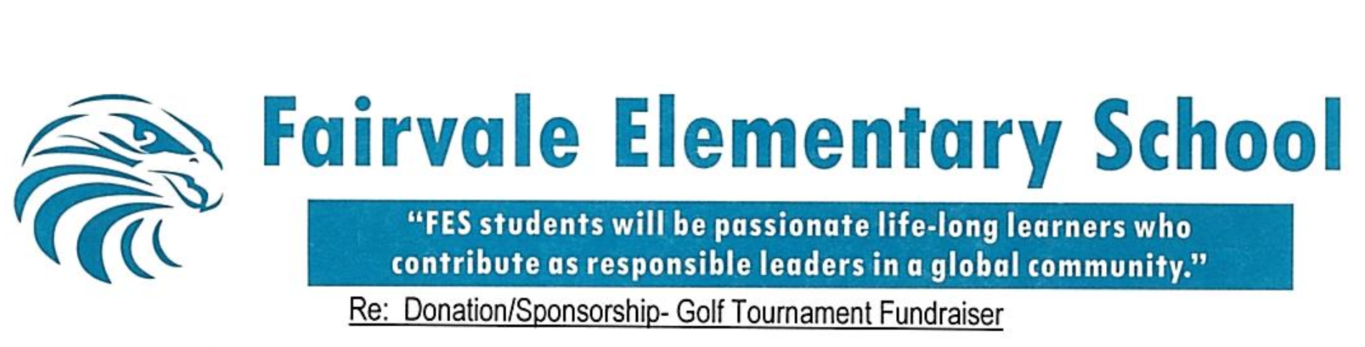

Dear Business Owner,

We hope this message finds you well. We are writing on behalf of the Fairvale Elementary Home & School Committee and are excited to be hosting our 2nd Annual Golf Tournament and Silent Auction on June 13, 2026, at Hampton Golf Course.

One of the most cherished features of Fairvale Elementary School is our well-known Ultimate Dreamland Playground. This playground has been enjoyed by countless students, families, and community members over the years. With time, age, and heavy use, it is now in need of major—and costly—upgrades to ensure it remains a safe and enjoyable space for years to come.

This tournament brings together local golfers, businesses, and community members for a fun day of connection and friendly competition, all while supporting much-needed playground improvements. We are reaching out to valued local businesses like yours to request support in the form of a donation, hole sponsorship, or team registration.

Contributions may include monetary donations, gift certificates, products, or services and will directly support the success of this event. In our first year, we were proud to raise $9,000, and with your help, we truly believe we can exceed that goal this year. In appreciation of your support, your business will receive recognition through social media promotion, hole signage, and/or acknowledgment as a silent auction donor. We are also happy to discuss customized sponsorship opportunities that best align with your business.

Local businesses play an essential role in strengthening our community, and your support would make a meaningful impact on our students and families. We would be happy to provide additional information or answer any questions at your convenience.

Thank you very much for your time and consideration. We sincerely hope you will consider partnering with us for this exciting event. Please don’t hesitate to reach out if you have any questions.

Warm regards,
Ally Percy (506-333-8856)
Madison Roy (506-645-7572)
Fairvale Home & School Tournament Coordinators
✉️ fairvalegolf@gmail.com

Please see the attached page for detailed information on how to donate or participate.


If you are interested in supporting our tournament, we offer several ways to get involved:

- Provide a Donation
We will be hosting a silent auction as well as multiple contests throughout the tournament. Donations of any kind—gift certificates, products, or services—are greatly appreciated and will be used for these activities.

- Basic Hole Sponsorship
Sponsor a hole (or multiple holes) with a donation of $150 per hole. Your business name will be displayed on signage placed on the course for promotional purposes during the tournament.

- Hole-in-One Sponsorship
Interested in sponsoring a $10,000 hole-in-one prize for approximately $250? Ask us how!
Limited to 1–2 sponsors. SPOT HAS BEEN FILLED!

- Enter a Team
Love to golf? This tournament is open to the public, and we are currently seeking teams of four players. Team registration: $600, which includes green fees, a golf cart, and a meal following the tournament.

- Monetary Donation
Monetary donations of any amount are accepted and very much appreciated.

Payment & Tax Receipt Information

For team registrations or monetary donations over $25, an income tax receipt can be issued by the district.

Please make cheques payable to “Minister of Finance” and include “For Fairvale Elem. Playground” in the notes section.

Thank you so much for taking the time to consider supporting our tournament. The children of our community truly thank you.

